

**Project Report On**

**Hudson Furnishing**

**Table Of Contents**

1. **Acknowledgments**
2. **Information About Developers**
3. **Introduction About Project**
4. **Analysis**
5. **Screen Shots**
6. **Final Statement**

**Acknowledgments**

The combine Study on this project is an honor for our group members.

We were eager to make such a dynamic and interesting project, which may provide us with a huge amount of practical knowledge and will help us use our skills efficiently.

Our heartiest appreciation and gratitude towards our teachers, whose help, dedication and encouragement has helped our team members to successfully, achieve our goals.

We are grateful to Aptech for providing us necessary facilities and the support which we needed and also for providing us the opportunity to practically implement what we have learned, which will help, help us in future.

**Information About Developers**

|  |  |
| --- | --- |
| Student1424565 | Sumbul Ahmed |
| Student1425773 | Warda Shah |
| Student1424829 | Laiba |
| Student1430589 | Mah Rukh Zia |

**Introduction About Project**

The Hudson Furnishing website is a captivating online platform developed to showcase the exquisite range of furniture products and services offered by the company.

This project seamlessly combines HTML, CSS, JavaScript, jQuery, and Bootstrap to create an immersive and user-friendly website that caters to both aesthetic appeal and functionality.

By leveraging modern web technologies, the website provides a visually stunning experience while ensuring seamless navigation and easy access to information.

Whether it's exploring the extensive product catalog, requesting a quote, or contacting the company, the Hudson Furnishing website offers a delightful online presence for users to discover and engage with the world of exceptional furniture.

**Analysis**

**Purpose**

The purpose of the Hudson Furnishing website is to create an immersive online platform that showcases the diverse range of furniture products and services offered by the company.

This project aims to provide a visually appealing and user-friendly website that effectively communicates the company's brand identity and values to potential customers.

By offering a seamless browsing experience, detailed product information, and convenient contact options, the website's purpose is to attract and engage users, driving interest in the company's furniture offerings and facilitating potential sales.

**Working**

Users can browse through the website's product catalog and discover a wide range of furniture offerings. They can view product details, such as descriptions, prices, dimensions, and images, to gain a better understanding of the available options.

The website provides information about the services offered by Hudson Furnishing, such as interior design consultation and custom furniture options. Users can explore these services to determine if they align with their needs and preferences.

**Snapshots**

**Home page**

This is the home page of website

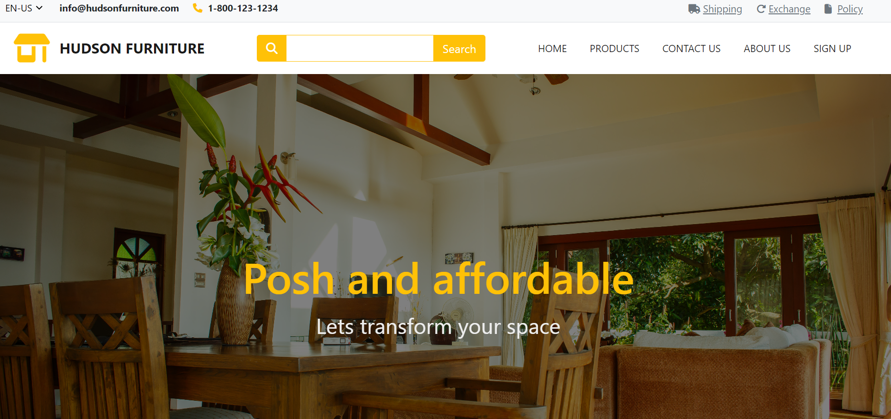

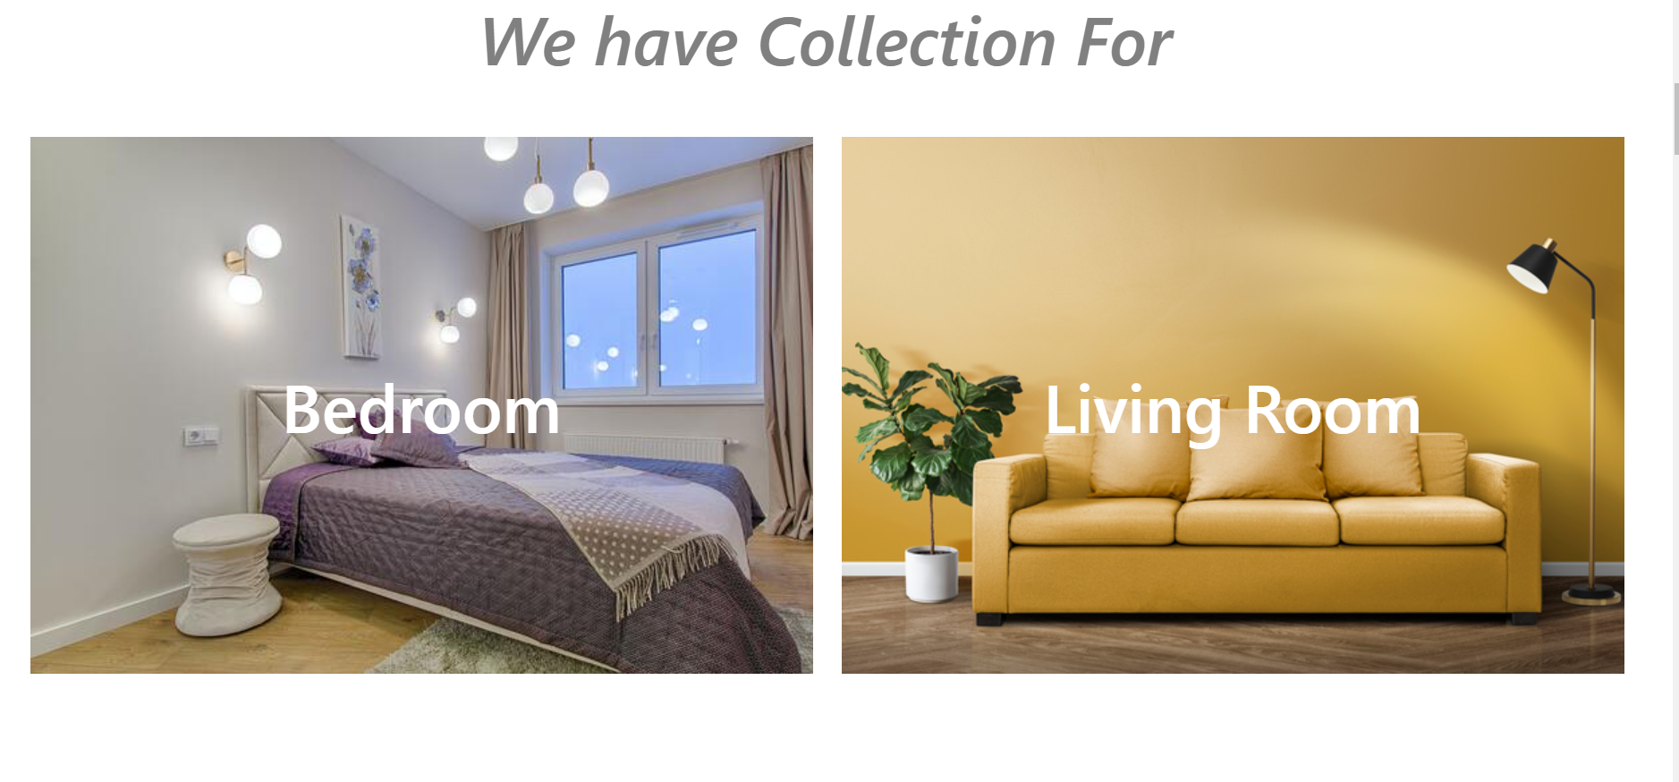 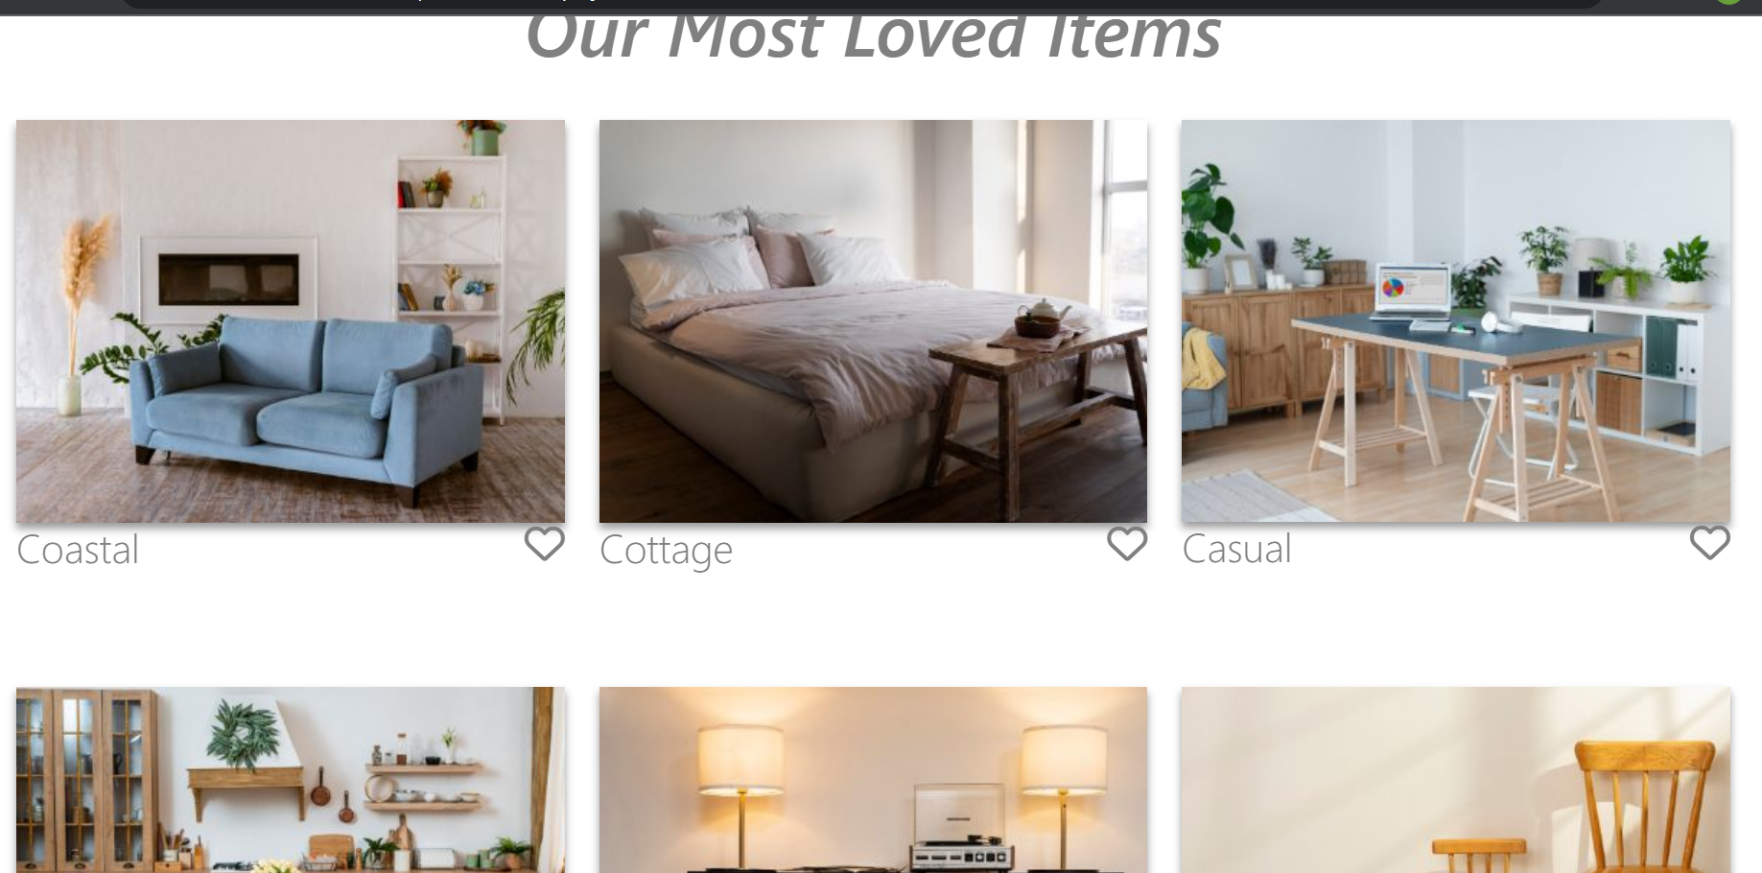

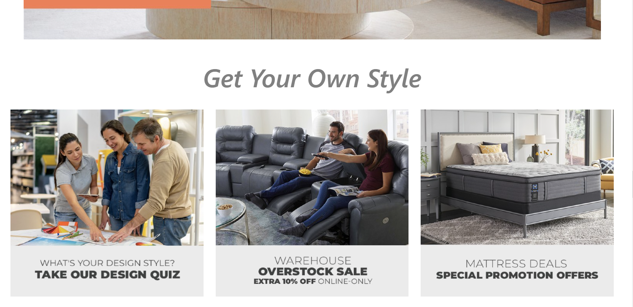 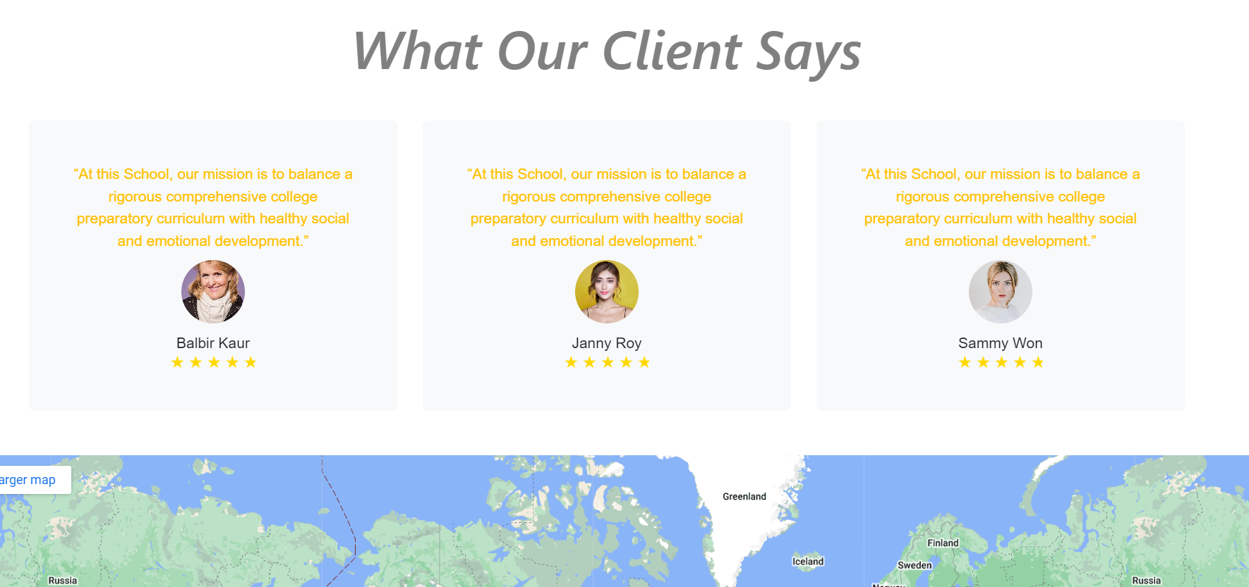

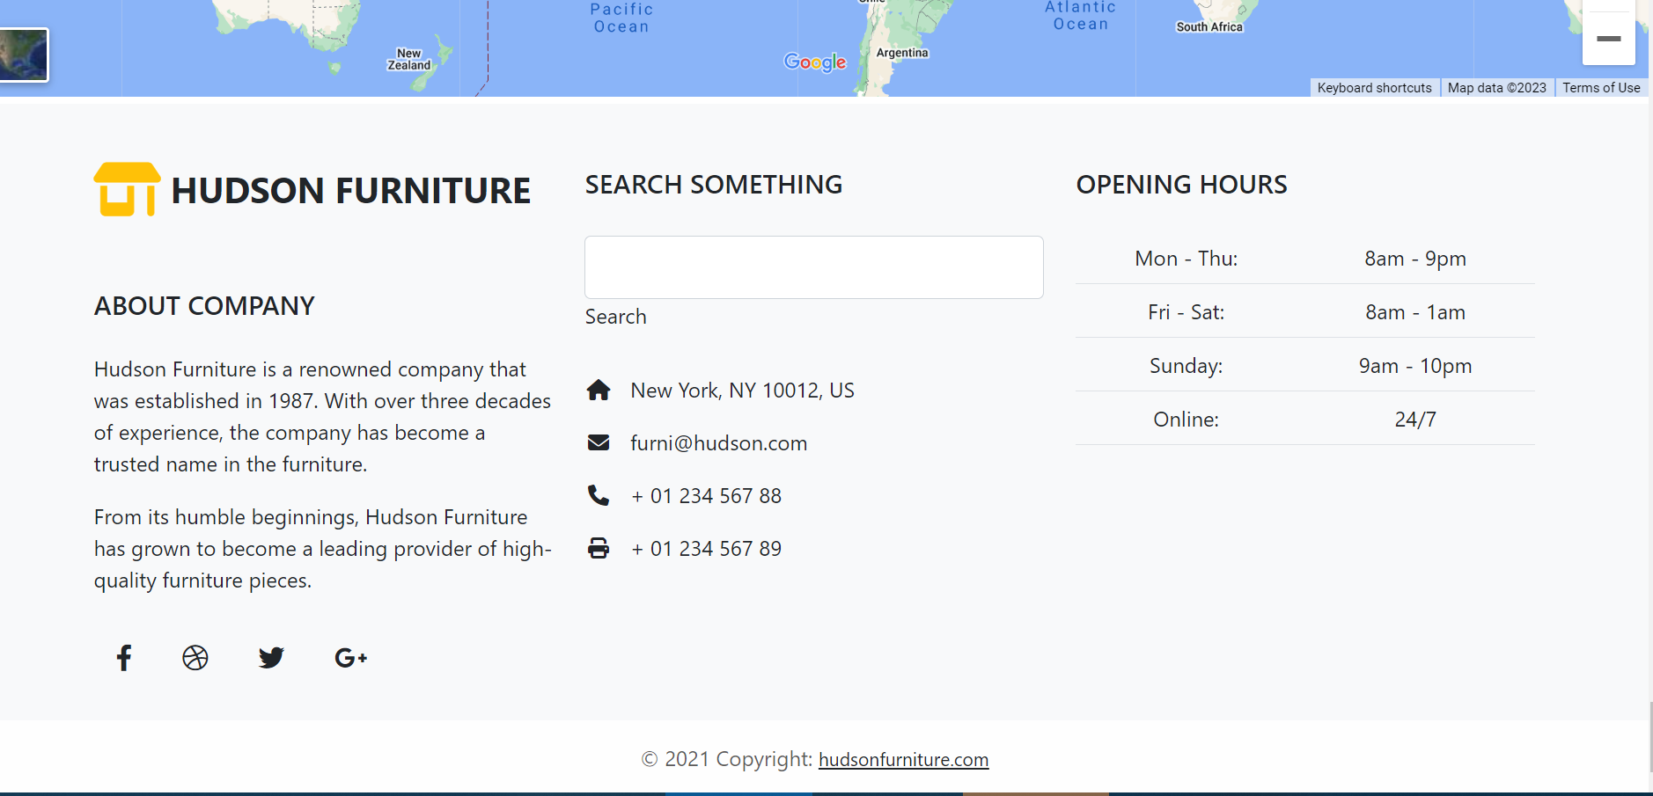

**Product page**

From this page customer can shop and explore furniture

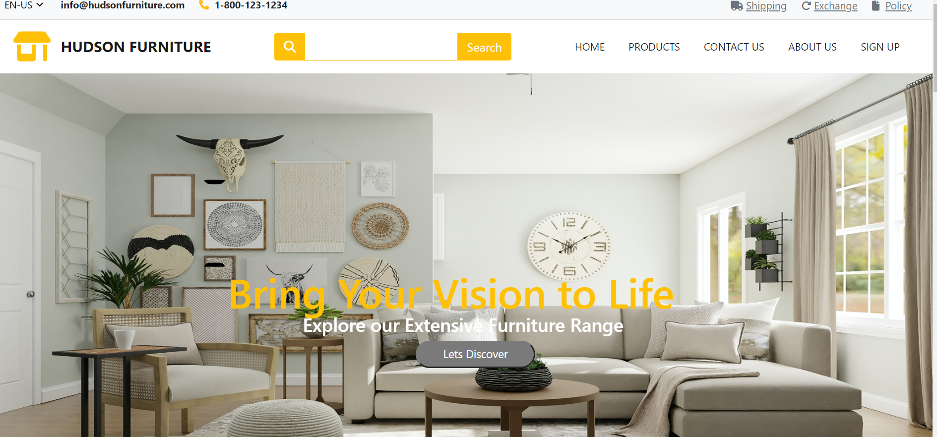 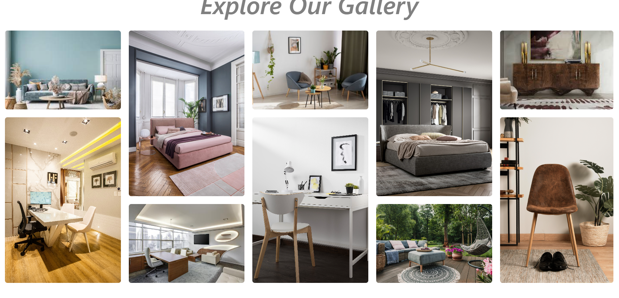 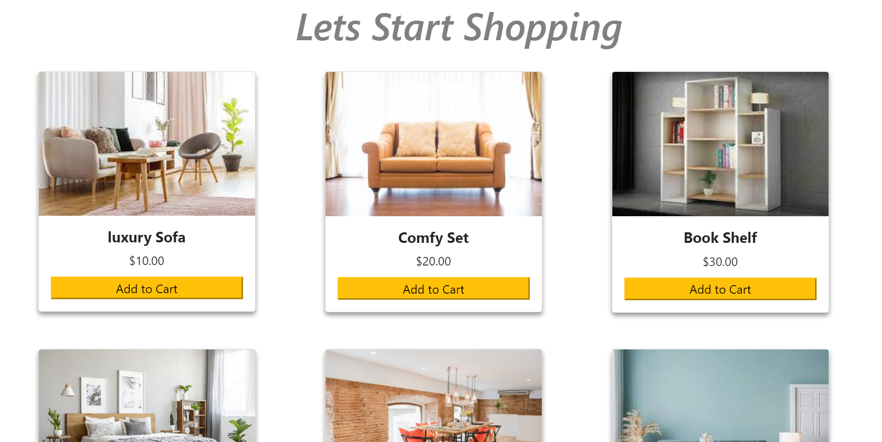

**Contact us page**

Customers can contact us through this page

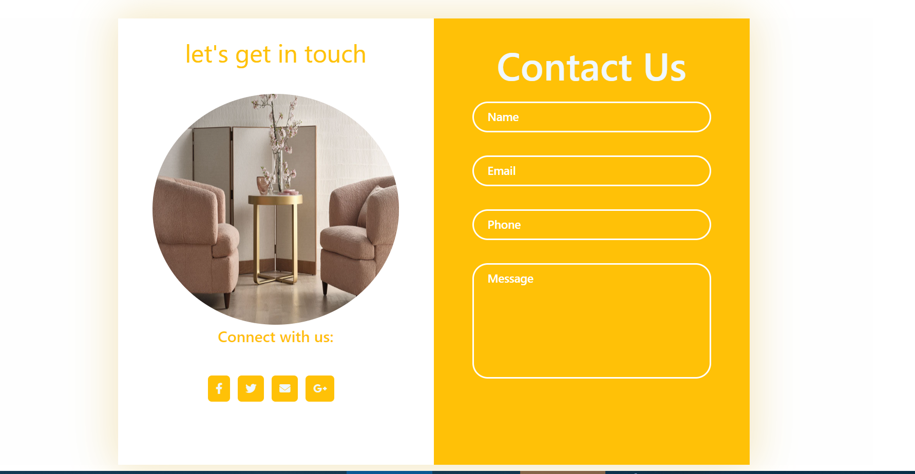

Through this map customers can visit our store

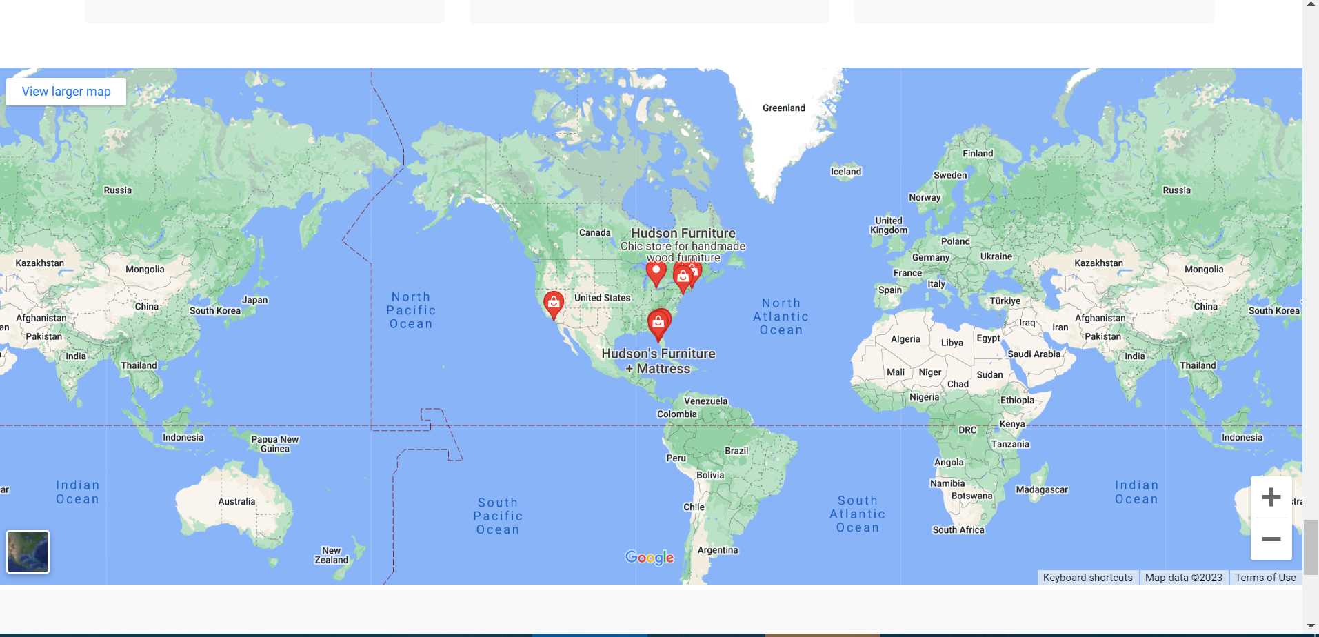

**About us page**

From this page customer can know our goals and history and team

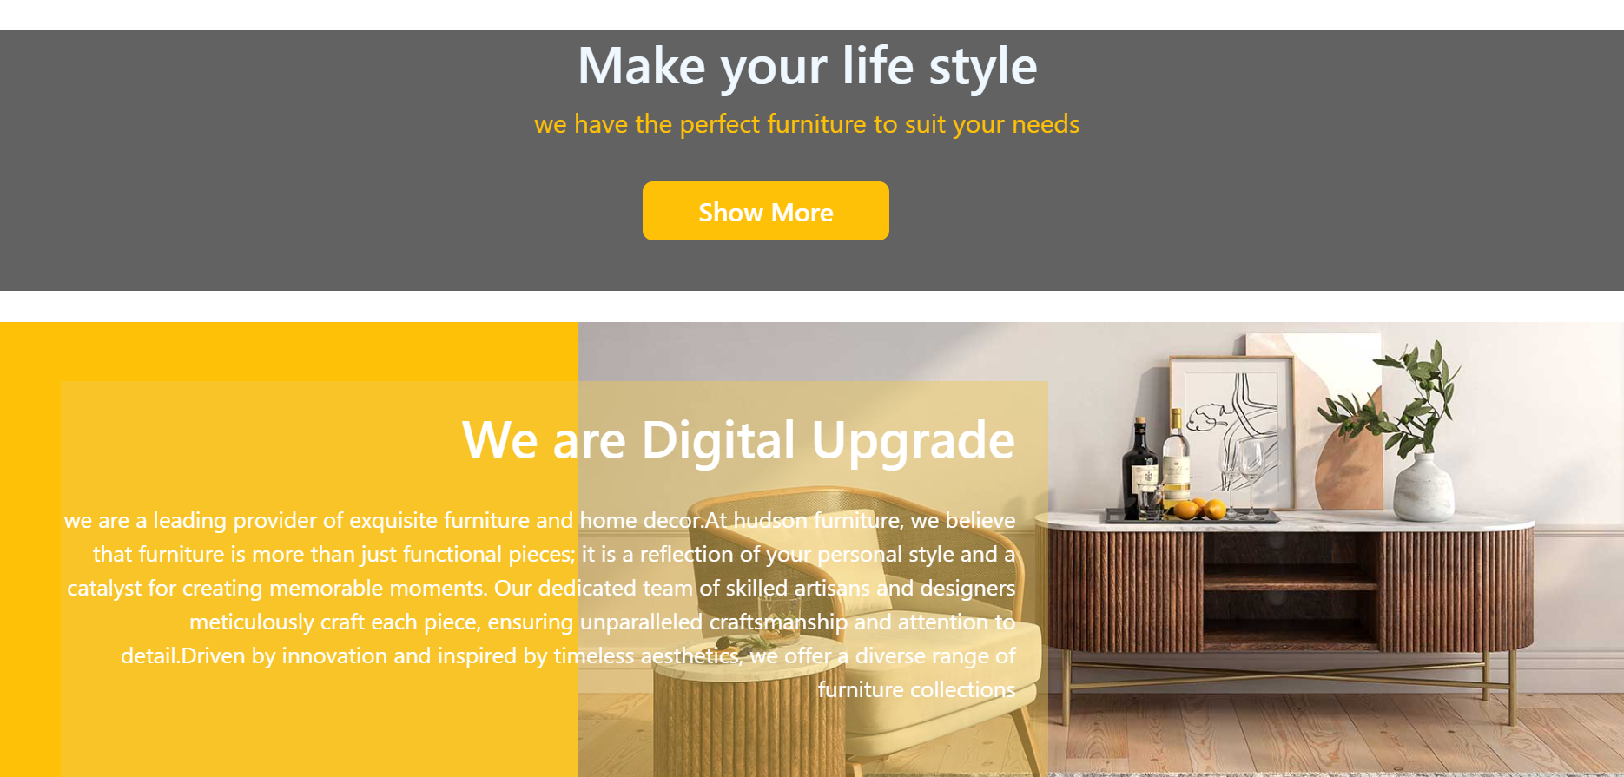 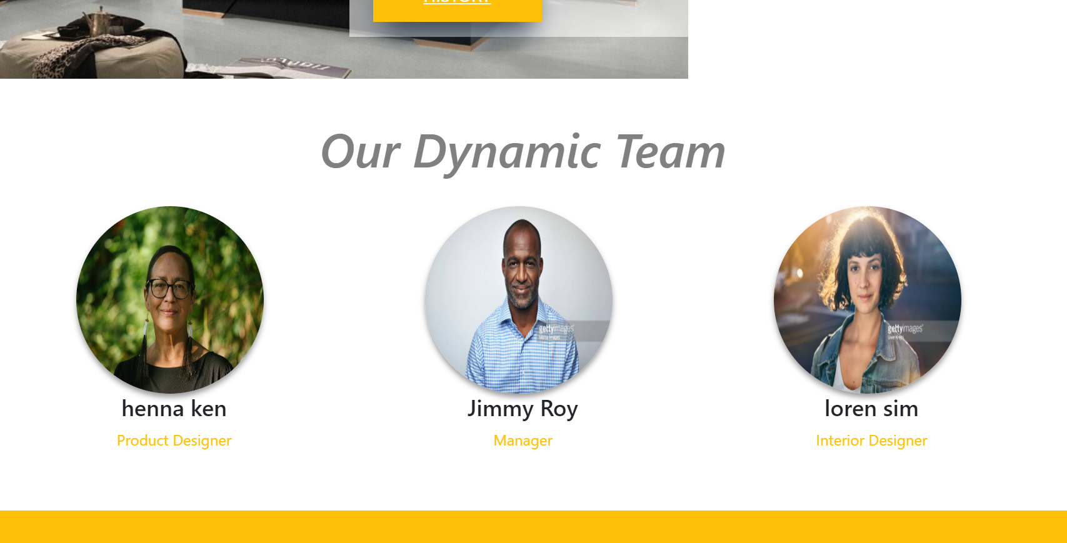 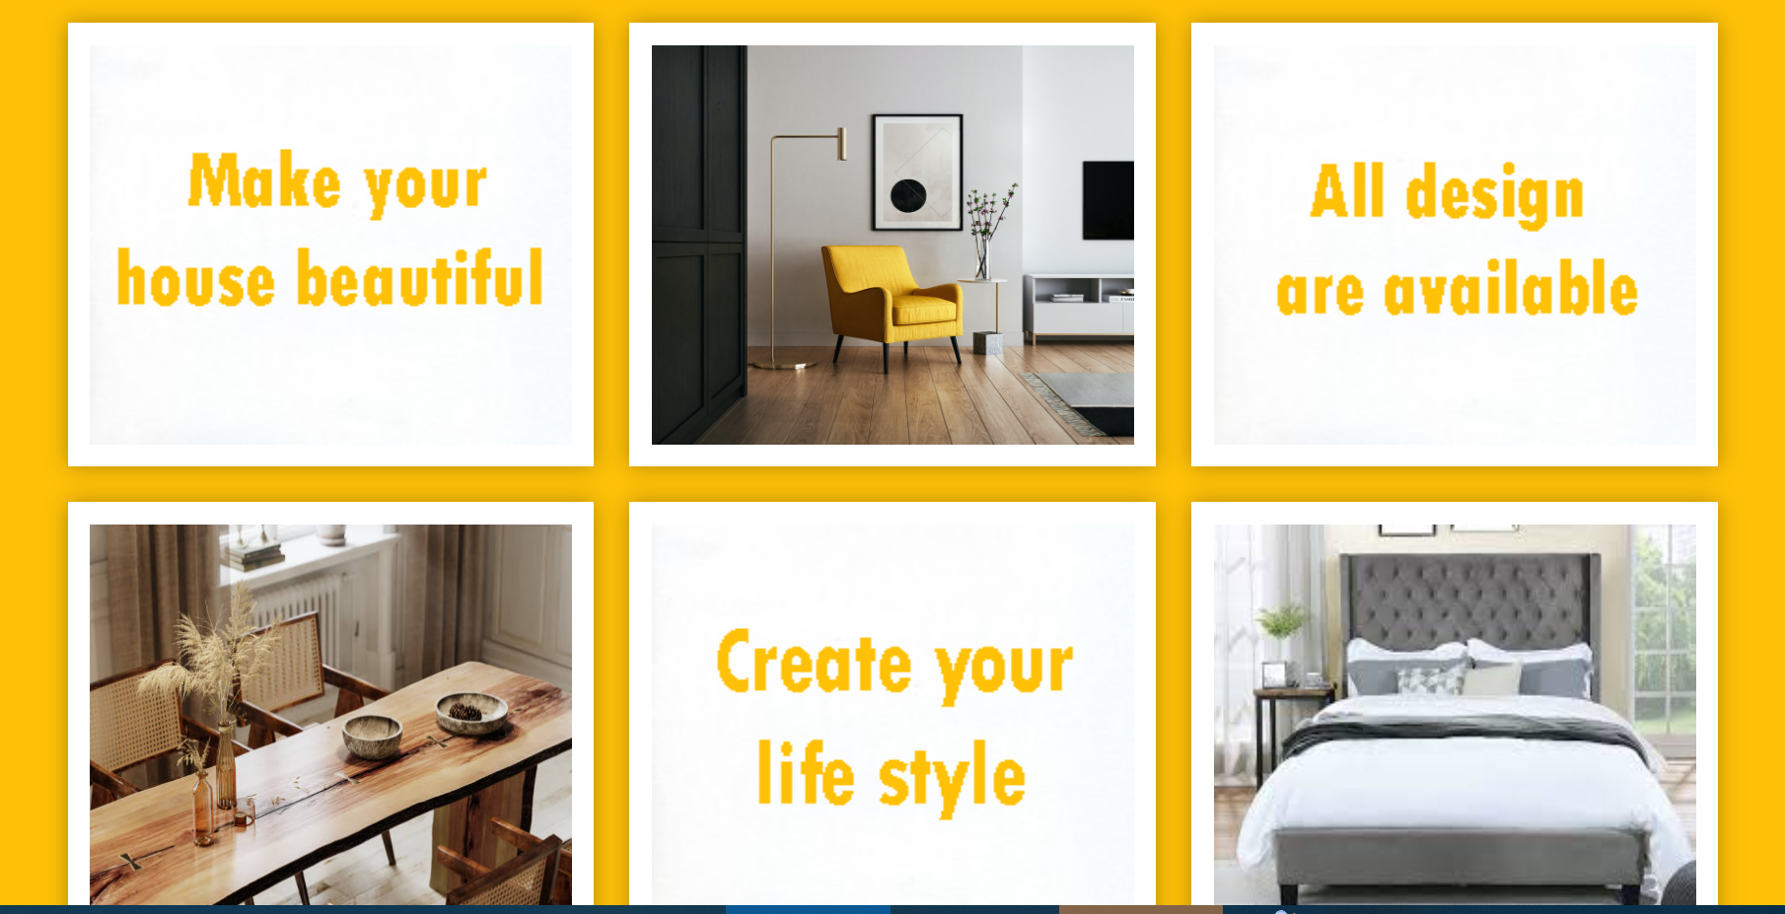

**Signup page**

From this page customer can sign up stayed connected with us

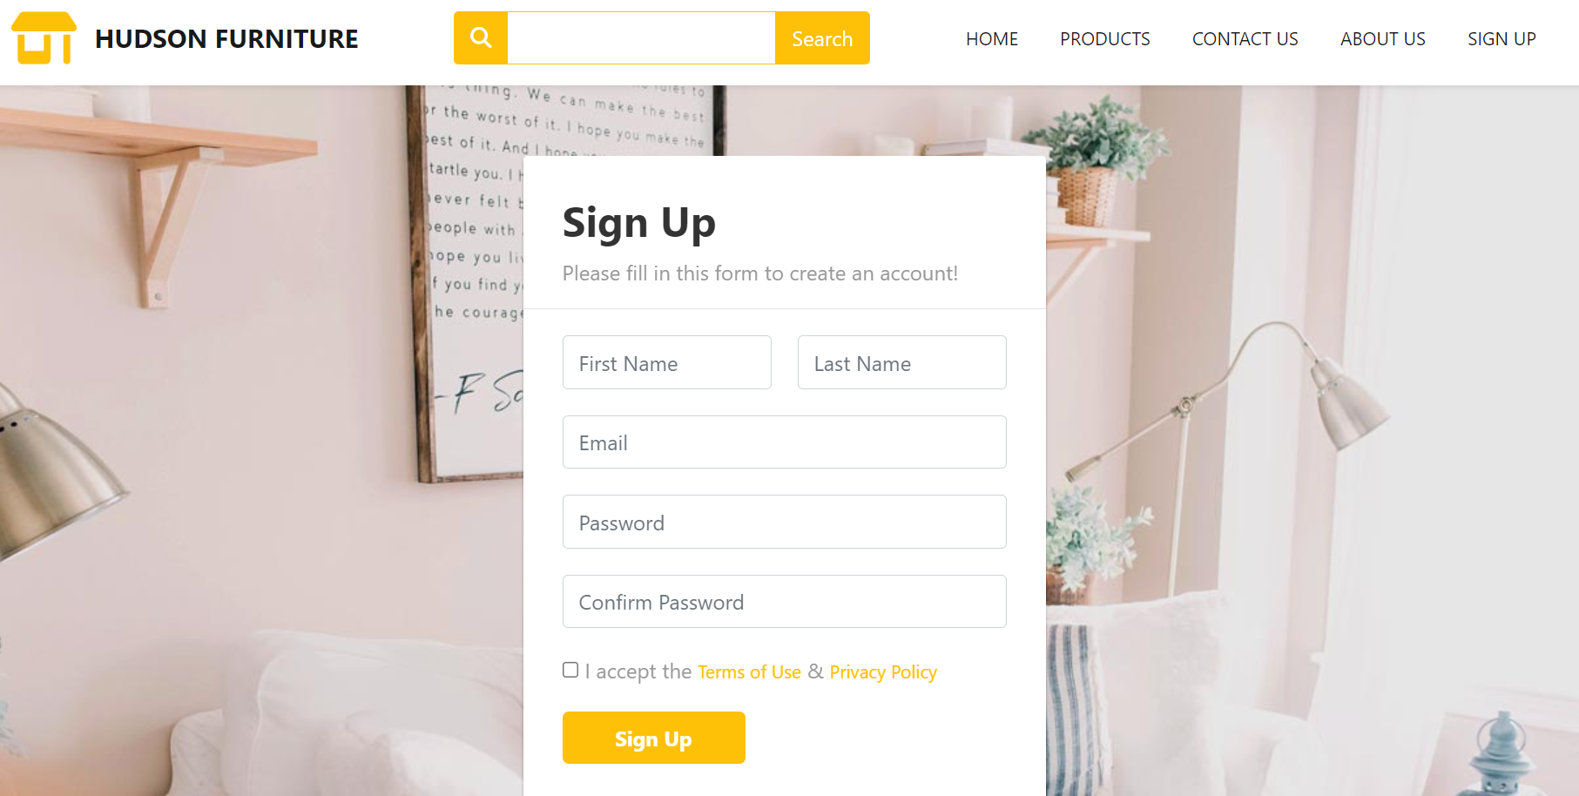

**Track order page**

From this page customer can track their order

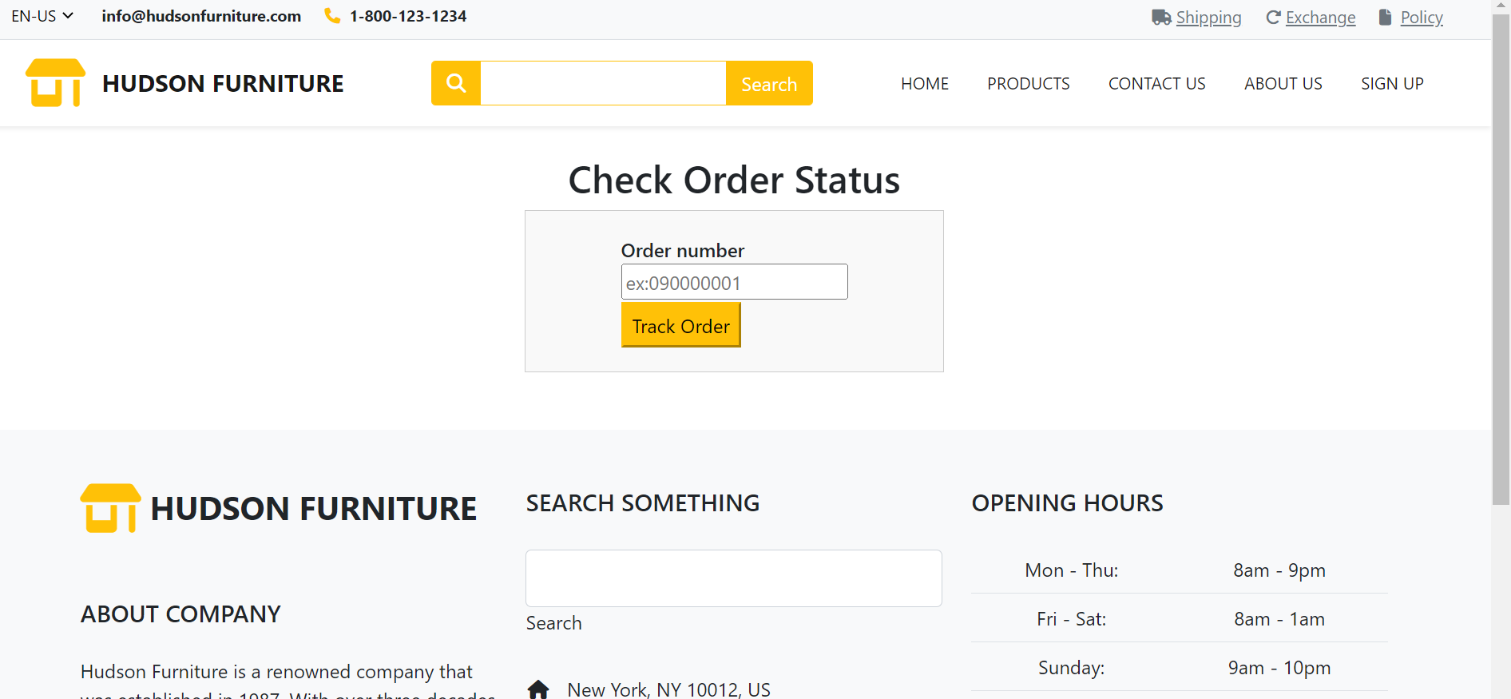

**Exchange product page**

From this page customer can exchange their product

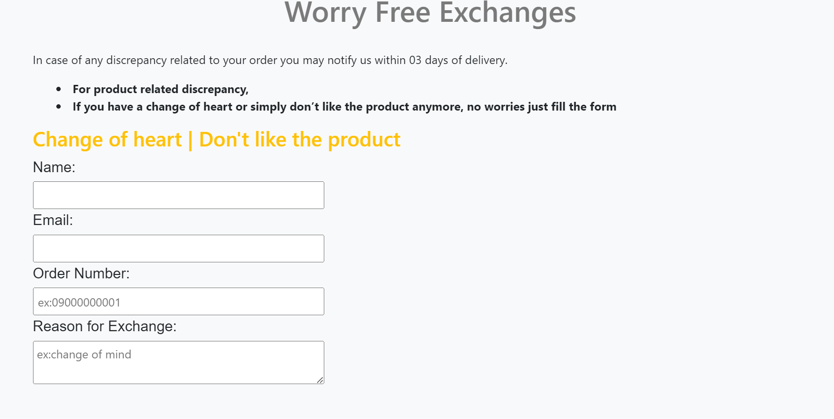

**Policy page**

From this page customer can know about our policies

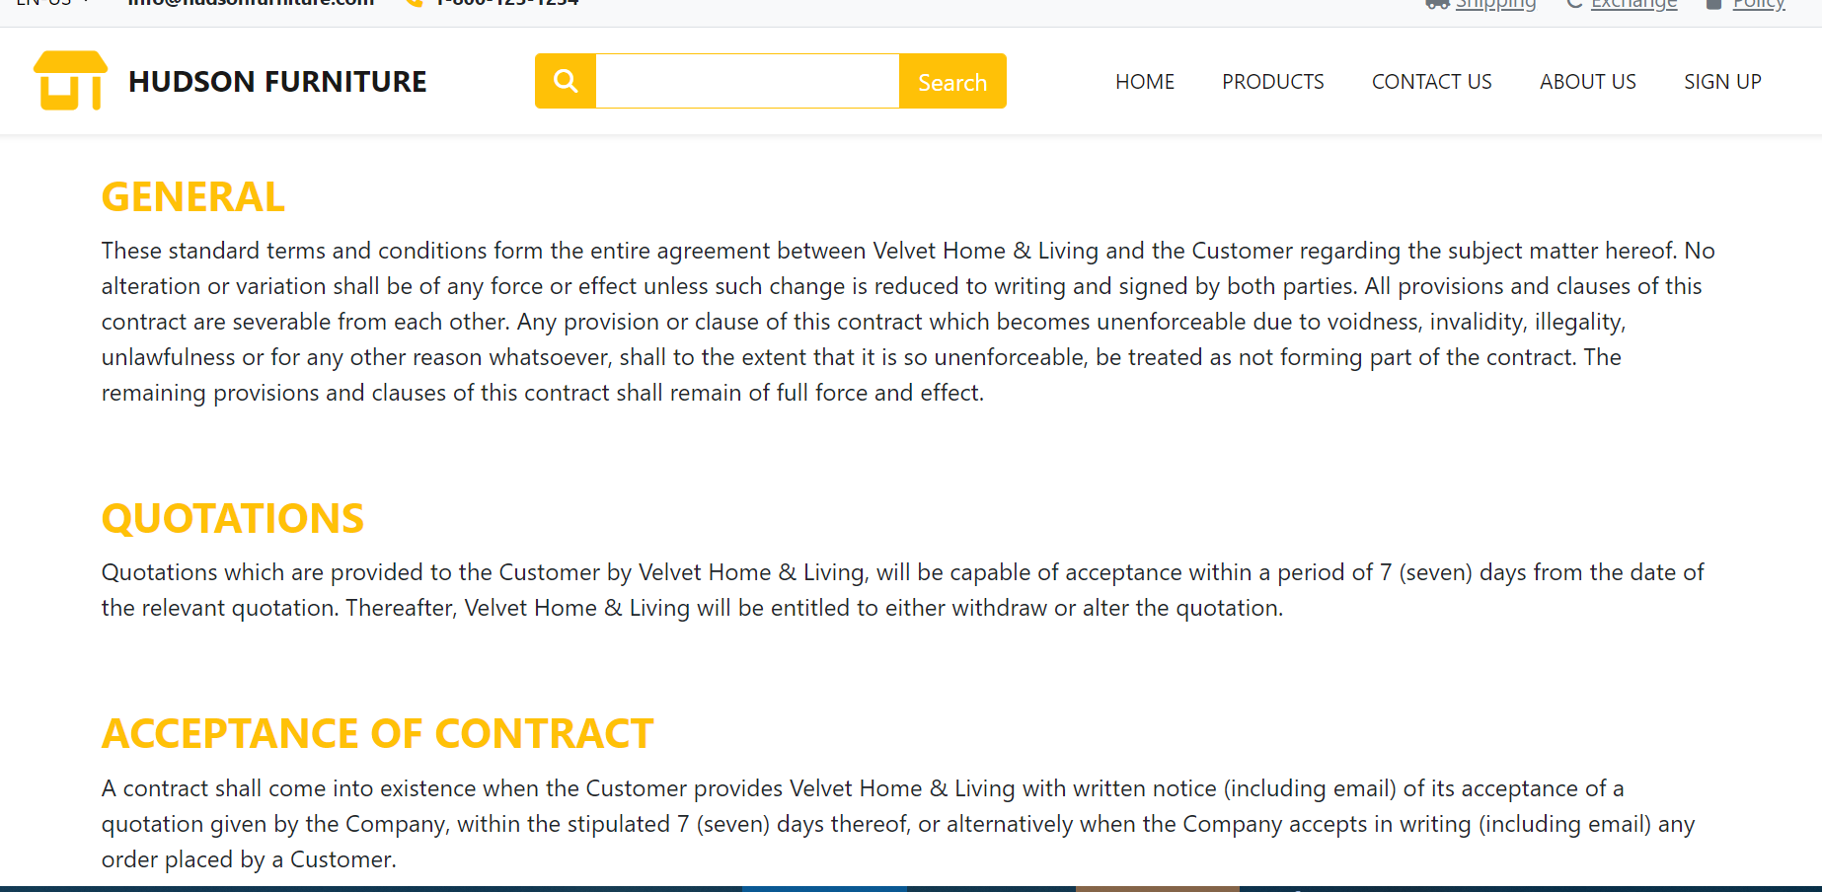

**Final Statement**

This E Project was created with Firm Determination. We students did lot of hard work to complete this project on time.

We did our best to made this project perfect, work full, help full, easy to use and Qualified as much as possible.

We Kept the future technologies and usage in our mind while making this project.

We hope That APTECH will like our project and will appreciate our hard work and Firm Determination.

THANK YOU!

**Documentation Created By**

**Sumbul Ahmed**